TABLE OF CONTENT

1 WEBSITE DESIGN 2

2 GRAPH REPORT 3

3 TABLE REPORT 5

4 Settings 6

5 Position fomula 7

Patient Position Monitoring 7

Position detection 7

Help/Info 10

# WEBSITE DESIGN



#### Feature 08: Position Monitoring

On the Track My Health home page,

the user can select the Position Monitoring feature icon.

This will direct them to the Position Monitoring page.

On the Position Monitoring page, the system will display a Graph button and a Table button, below the Position Monitoring sub-header.

# GRAPH REPORT

If the user selects the Graph button, they can opt to view their **Position Monitoring graph**, or their **raw data** Activity graph. They can view their the raw data Activity graph by selecting the Raw data button above the graph (on the right side of the screen).

**KIỂU XEM BÌNH THƯỜNG (DEFAULT)**

With the Position Monitoring graph, the user will see a graph with an x-axis and a y-axis.

**TRỤC X:**

The x-axis will reflect the date/time parameters of the data recordings, while the

Under the graph, the user can select the Date/Time section to display a pop-up calendar. This will allow the user to select a desired start and end date/time.

**TRỤC Y:**

y-axis will show the user's **color-coded sleep position**; such as

|  |  |
| --- | --- |
| **Supine (blue - lying with face up)** |  |
| **Prone (red - lying with face down)** |  |
| **Left (purple),** |  |
| **Right (orange)** |  |
| **Up (green)** |  |
| **Down (turquoise green).** |  |

Please refer to the formula document for further details on any parameters, or measures, listed in this section.

**NỘI DUNG GRAPH:**

Within the graph, the system will display **dots** that represent the user's sleep position over time.

However, if there is no data to display, then there will be a

**notification** that states

***"You have no data to graph."***

**KIỂU XEM RAW DATA**

In looking at the raw data Activity graph, the user will also see a x-axis and a y-axis.

**TRỤC X:**

The x-axis will still reflect the date/time parameters of the data recordings.

**TRỤC Y:**

However, the y-axis will represent the **raw g-values** over time (i.e. X, Y, and Z variables).

Within the graph, the system will detail a color-coded line for each variable.

**raw g-values:** Each line will represent the raw g-value data recorded over time.

|  |  |
| --- | --- |
| **X** | X will be green |
| **Y** | Y will be red |
| **Z** | Z will be blue |

# TABLE REPORT

Aside from a graph, the user can select the Position Monitoring Table format.

**KIỂU XEM BÌNH THƯỜNG (DEFAULT)**

With the table format, the system will display several columns to represent

|  |  |
| --- | --- |
| **Date/Time** | the user can select Date/Time and a pop-up calendar will display for the user to select the desired start and end date/time. |
| **Position** |  |
| **Alarm** |  |

Under each column header (i.e. Date/Time, Position, etc.), there will be several entry fields to reflect the data collected over time for each category.

**KIỂU XEM RAW DATA**

As with the graph, the user can view the Activity table in raw data format.

With the raw data Activity table, the system will display several **columns** that represent

Date/Time and the raw g-values (i.e. X, Y, and Z variables).

|  |  |
| --- | --- |
| **Date/Time** | For the Date/Time field, the user can select Date/Time and a pop-up calendar will display for the user to select the desired start and end date/time. |
| **X** | variables |
| **Y** | variables |
| **Z** | variables |

Under each table header (i.e. Date/Time, X, etc.) there will be several entry fields to reflect the data collected over time for each category.

**PHẦN DIAGNOSIS**

Below the graph/table section, the system will display a Diagnosis and Recommendations field.

Initially, the Diagnosis and Recommendations section will have a

**notification** that reads

***"This page displays your current medical issues and the date that they were noted in your medical record. Click on the issue name for more in-depth information on that particular issue."***

By following the notification directions, the user will be able to retrieve details about their current diagnosis and previous diagnoses. It will also detail recommendations based on the diagnoses provided.

**BUTTONS**

Beneath Diagnosis and Recommendations, there will be a **Settings button** and a **Back to Track My Health button**.

If the user selects the Settings button, they will be directed to the Position Monitoring Settings page.

However, if the user selects the Back to Track My Health button, then they will be transferred to the Track My Health home page.

# Settings

On the Position Monitoring Settings page, the system will display a

**notification**, under the Position Monitoring Settings sub-header, that states

***"This page displays the current settings of this feature."***

Below the notification, the user will see **settings categories** that the user can change; For each category, the user can choose the desired settings . such as

|  |  |
| --- | --- |
| **Sample rate** | For example, the user can select a five minute interval for Sample rate |
| **Alarm position** | Below the Sample rate setting, the user also has the option to modify the Alarm position setting by selecting the check box of any/all of the sleep positions that they wish to be alerted for (e.g. Supine, Prone, etc.). |

***Xem mục 4.***

***Please refer to the formula document for further details on any parameters, or measures, listed in this section.***

**BUTTONS**

Below the Position Monitoring settings, the user will see **Edit, Cancel, Save, and Back buttons**.

If the user chooses to edit their settings, they will need to select the Edit button and make the desired changes.

Once the changes are made, the user will select the Save button so that the desired settings are saved.

However, if the user wants to cancel any changes, then they will select the Cancel button and no changes will be saved.

The user can also select the Back button. This will take them back to the Position Monitoring page.

# Position fomula

### Patient Position Monitoring

In many cases, it is necessary to monitor the body positions and movements made because of their relationships to particular diseases (i.e., sleep apnea and restless legs syndrome).

Analyzing movements during sleep also helps in determining sleep qualityand irregular sleeping patterns.

The body **position sensor** could help also to detect fainting or falling of elderly people or persons with disabilities.

The Patient Position monitors **six different patient positions** (**supine, prone, left, right, up sitting/standing, and down sitting/standing)**

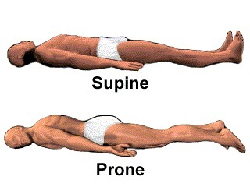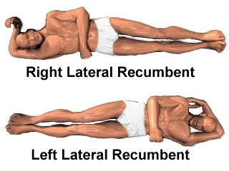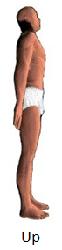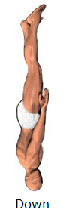

* Supine: Someone in the supine position is lying on his or her back.
* Prone: Someone in the prone position is lying face down.
* Right Lateral Recumbent: The Right lateral recumbent, or RLR, means that the patient is lying on their right side.
* Left Lateral Recumbent: The left lateral recumbent, or LLR, means that the patient is lying on their left side.
* Up: Someone in the up position is sitting/standing up.
* Down: Someone in the down position is sitting/standing down.

### Position detection

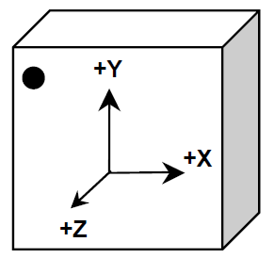

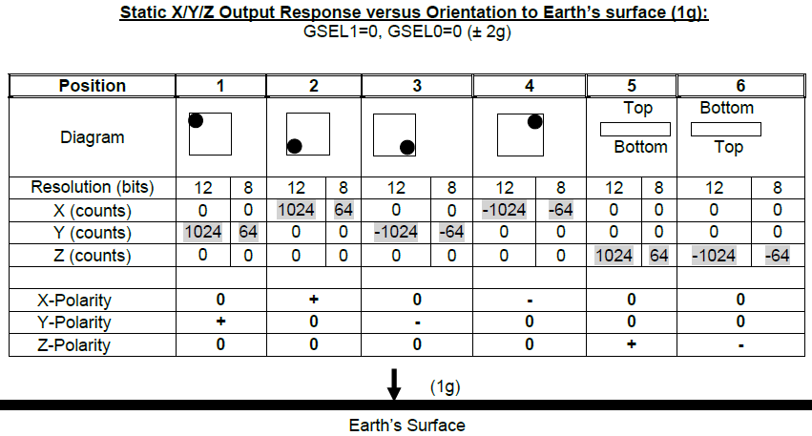

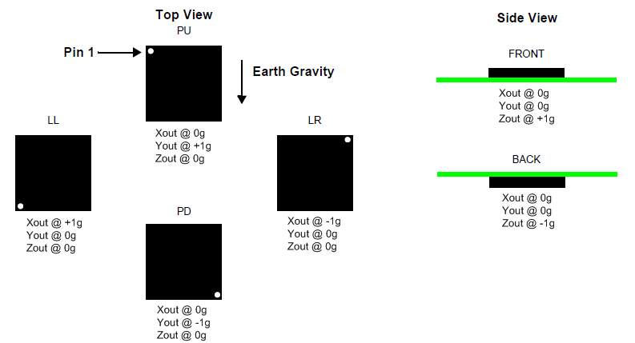

The figure shows the device configuration in the six different orientation modes. These orientations are defined as the following:

**PU = Portrait Up,**

**LR = Landscape Right,**

**PD = Portrait Down,**

**LL = Landscape Left,**

**FRONT and BACK side views.**

Depending on how the accelerometer is located, the Patient positions will be matched with the accelerometer positions.

For example, in case the top view of accelerometer is located up (opposite to earth gravity direction) and pin 1 is at the same direction of patient head.



|  |  |  |  |  |
| --- | --- | --- | --- | --- |
| Xout | Yout | Zout | Accelerometer | Patient |
| 0 | 0 | 1 | Front | Supine |
| 0 | 0 | -1 | Back | Prone |
| 0 | 1 | 0 | PU | Up |
| 0 | -1 | 0 | PD | Down |
| 1 | 0 | 0 | LL | Right Lateral |
| -1 | 0 | 0 | LR | Left Lateral |
| x | x | x | x | Undefined |

In case the top view of accelerometer is located up (opposite to earth gravity direction) and pin 1 is opposite to patient head.



|  |  |  |  |  |
| --- | --- | --- | --- | --- |
| Xout | Yout | Zout | Accelerometer | Patient |
| 0 | 0 | 1 | Front | Supine |
| 0 | 0 | -1 | Back | Prone |
| 0 | 1 | 0 | PU | Up |
| 0 | -1 | 0 | PD | Down |
| 1 | 0 | 0 | LL | Left Lateral |
| -1 | 0 | 0 | LR | Right Lateral |
| x | x | x | x | Undefined |

The rawXout, Yout, Zout values should be preprocessed using thresholding before they are used for position detection. The temporary threshold for each axis is+/- 0.2g as defined below:

$$X= \left\{\begin{matrix}0 & \left|X\right|<0.2 \\ 1 & X>0.8 \\ -1 & X< -0.8\end{matrix}\right.$$

### Help/Info

Information about Position features: refers above.